**Statistical Analysis of Consumption of Resources at Global Scale**

**GitHub -Link:**  **https://github.com/Hemanthtak2000/Applied-Data-Science-1--assignment2.git**

***Abstract:*** *Crucial role of Resources has beenexplored with the help of statistical analysis. The analysis took place in various graphical format which allowed to compute as well as measure the scale of consumption of renewable resources. The study also shed lights over the aspects mutually influenced by this consumption and other associated factors also has been discussed.*

1. **INTRODUCTION**

Two forms of resources termed as renewable and non-renewable are often consumed by the industries to fulfill the requirement of energy. However, renewable sources of energy are considered to be suitable for environment. Despite of use of renewable sources of energy, the problem of CO2 emission is yet sustained in the environment. The purpose of this analysis is to explore all the responsible aspects and conduct study on these aspects with respect to CO2 and other related parameters.

1. **DESCRIPTION OF GAINED RESULTS**

The emission of Carbon Dioxide happens due to burning of fossils or petroleum products by people. In other words, the population density is directly proportional to the volume of CO2 emitted. It has been precisely depicted by the following picture as:

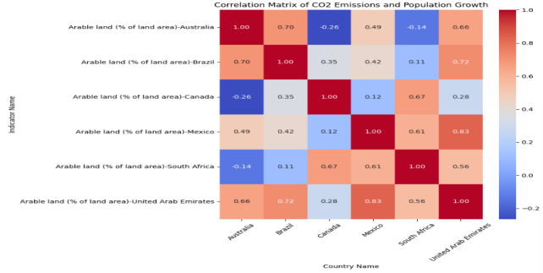

From the above correlational matrix, it has been observed that there are multiple variables making relationships among each other. The value ‘1’ over the red boxes exist diagonally showcased the positive true effectively. In this matrix, arable land’s value for countries like Australia, Brazil, Canada, Mexico, South Africa and United Arab Emirates are given. The values like ‘-0.26’ or ‘-0.14’ indicate a strong false positive. Similarly, the values in this matrix conveys the values like ‘0.70’ or ‘0.83’ conveys moderate positive true in terms of CO2 emission with respect to the population density of these nations.

Similarly, a trend of Australia has been measured in the following image with the help of Arable land and renewable energy consumption given as below:

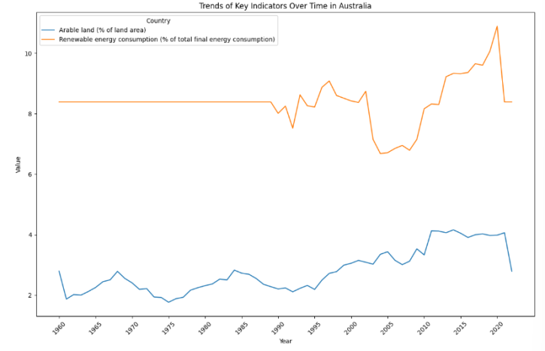

It can be seen from the above image that a straight line is drawn for arable land till it reaches to near 1990 and all of a sudden, a major fluctuation has been started indicating the comprise of farming land by industries. In the meantime, this graphical presentation also depicts the consumption rate of renewable sources from the year 1960 to 2020 which has been found to be increasing in the nearby years.

The trends of Mexico shown in the below visualization also exhibits a comparable evaluation between the Arable land versus Renewable energy consumption rate:

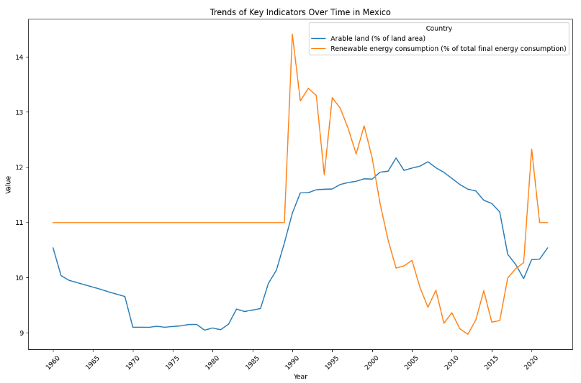

Arable land area or farmable land is straight till 1987 but a sudden hike as vertical line indicates an industrial intervention and sequentially, the availability of land decreases with the increasing use of renewable sources of energy. Hence, it shows a misadministration of Mexican government in handling the renewable sources of energy along with Arable land while overcoming the problem of CO2 emission.

The below columnar graph exhibits the same parameters that all the government of chosen countries have implemented as shown below:

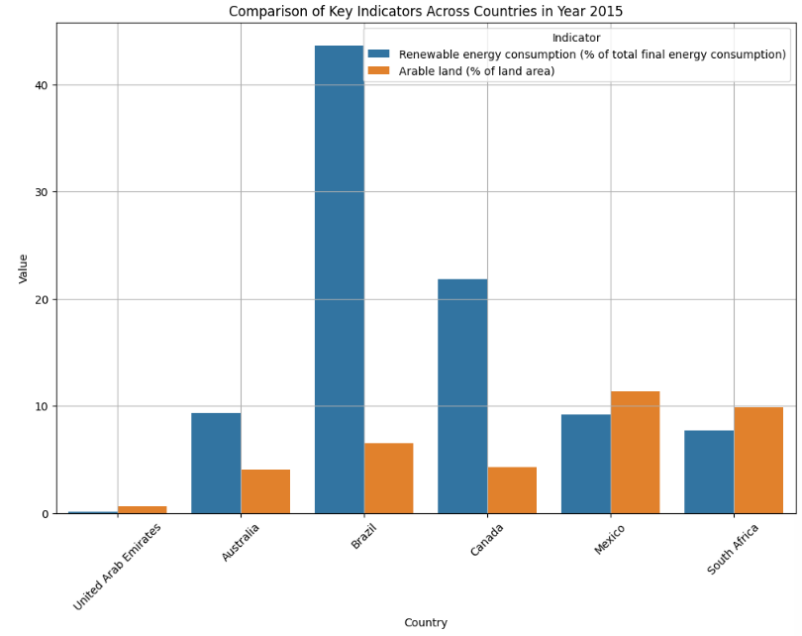

1. **CONCLUSION**

Based-on the analysis of Arable land and consumption of renewable sources, it has been learned that resolution of renewable sources of energy for overcoming the CO2 emission needs to be improved in terms of strategies and decision-making on behalf of governments.